FINAL PROJECT REPORT
India’s Agricultural Crop Production Analysis

Data Analytics with Tableau

Submitted by: Kimaya Jitendra Bhosale
Roll Number: 09

Institution: Indira College of Engineering and Management, Pune
Department: B.Tech – Artificial Intelligence and Data Science
Tool Used: Tableau Public

Table of Contents
1. Introduction
1.1 Project Overview
1.2 Objectives
2. Project Initialization and Planning Phase
2.1 Define Problem Statement
2.2 Project Proposal (Proposed Solution)
2.3 Initial Project Planning
3. Data Collection and Preprocessing Phase
3.1 Data Collection Plan and Raw Data Sources Identified
3.2 Data Quality Report
3.3 Data Exploration and Preprocessing
4. Data Visualization
4.1 Framing Business Questions
4.2 Developing Visualizations
5. Dashboard
5.1 Dashboard Design File
6. Report
6.1 Story Design File
7. Performance Testing
7.1 Utilization of Data Filters
7.2 Number of Calculation Fields
7.3 Number of Visualizations
8. Conclusion / Observation
9. Future Scope
10. Appendix
10.1 Source Code
10.2 GitHub & Project Demo Link

1. Introduction

1.1 Project Overview
Agriculture is the backbone of the Indian economy, supporting the livelihoods of a large share of the population and feeding over a billion people. Planning for food security, pricing, storage and policy depends on understanding how much is grown, where it is grown, in which season, and how productive the land is. However, the raw crop production data published for India is spread across many states, districts, crops and years, which makes it difficult to read as plain tables.
This project, “Agricultural Production Insights”, converts a state-wise and crop-wise agricultural production dataset of 345,407 records covering 1997-98 to 2020-21 into an interactive analytical solution built in Tableau Public. The work includes data cleaning and preparation, creation of a calculated yield measure, eleven worksheets that answer specific business questions, an interactive dashboard titled “Agricultural production insights”, and a Tableau Story that walks the viewer through the key findings.
At the whole-dataset level, the dashboard summarises roughly 4.03 billion units of cultivated area and 330.99 billion units of production, giving an overall yield of about 82 production units per area unit.

1.2 Objectives
The main objectives of the project are:
- To clean, prepare and model the Indian agricultural production dataset for analysis in Tableau.
- To create a calculated yield measure (production per unit area) and study its trend from 1997-98 to 2020-21.
- To identify the leading states by cultivated area and by agricultural production.
- To compare the cultivated area of major crops such as rice, wheat, cotton and soyabean.
- To analyse how production is distributed across seasons and across production unit types (Tonnes, Nuts and Bales).
- To combine the visualizations into an interactive dashboard with filters and action filters.
- To present the findings as a Tableau Story that can be shared with decision-makers.

2. Project Initialization and Planning Phase

2.1 Define Problem Statement
Policy makers, agricultural analysts and students need a quick way to understand long-term trends in Indian agricultural output. The available data is large, scattered over thousands of state, district and crop combinations, and recorded in mixed units and seasons. Without visual analytics, patterns such as which states lead production, how yield has changed over the years, and which seasons contribute most are hard to find.
Parameter | Description
Who is affected | Agricultural analysts, policy makers, researchers and students who study crop production.
What is the problem | Large, multi-dimensional production data (state × district × crop × season × year) is difficult to interpret in tabular form.
Why it matters | Decisions on food security, storage, subsidies and crop planning depend on understanding production, area and yield trends.
Desired outcome | An interactive dashboard and story that answer key questions about area, production, yield, season and state performance in a few clicks.

2.2 Project Proposal (Proposed Solution)
The proposed solution is a Tableau-based analytical dashboard that visualizes the dataset using KPIs, line, bar, map, pie and donut charts, and allows users to slice the data by Season, Year, Crop and State.
Component | Details
Project title | Agricultural Production Insights – India (1997–2021)
Proposed solution | Interactive Tableau dashboard and story built on a cleaned agricultural production dataset.
Key features | KPI summary (area, production, yield); yield trend; state-wise map; leading states; crop-wise area comparison; season share; production unit distribution; filters and action filters.
Tools and technologies | Tableau Public (data connection, worksheets, dashboard, story); spreadsheet / CSV data source.
Expected output | One dashboard, one story and eleven supporting worksheets published on Tableau Public.

2.3 Initial Project Planning
Phase | Activities | Output
Planning | Understand the domain, define problem statement and business questions. | Problem statement, list of questions
Data collection | Identify and download the dataset; inspect fields and values. | Raw dataset (Sheet1)
Preprocessing | Check quality, fix inconsistent names, create the yield calculation, build sets. | Clean data source in Tableau
Visualization | Build worksheets for each business question and format them. | Eleven worksheets
Dashboard and story | Assemble the dashboard, add actions and filters, build the story. | Dashboard and Story 1
Testing and reporting | Test filters and actions, publish to Tableau Public and prepare the report. | Final report, public link

3. Data Collection and Preprocessing Phase

3.1 Data Collection Plan and Raw Data Sources Identified
The project uses a single tabular source, loaded into Tableau from a Microsoft Excel connection as “Sheet1 (India’s Agricultural Crop Production Analysis)”. It contains 345,407 rows and 11 fields (including the yeild calculation) of crop production records for Indian states and districts across 24 agricultural years from 1997-98 to 2020-21.
Item | Description
Dataset | India’s Agricultural Crop Production Analysis (Sheet1)
Source | Public open dataset (Kaggle / government agriculture statistics) – [add source link]
Format | Microsoft Excel workbook connected to Tableau Public; cleaned with Data Interpreter
Size | 345,407 rows × 11 fields
Coverage | Years 1997-98 to 2020-21; states and union territories of India; multiple crops and seasons
Granularity | One record per State–District–Crop–Season–Year

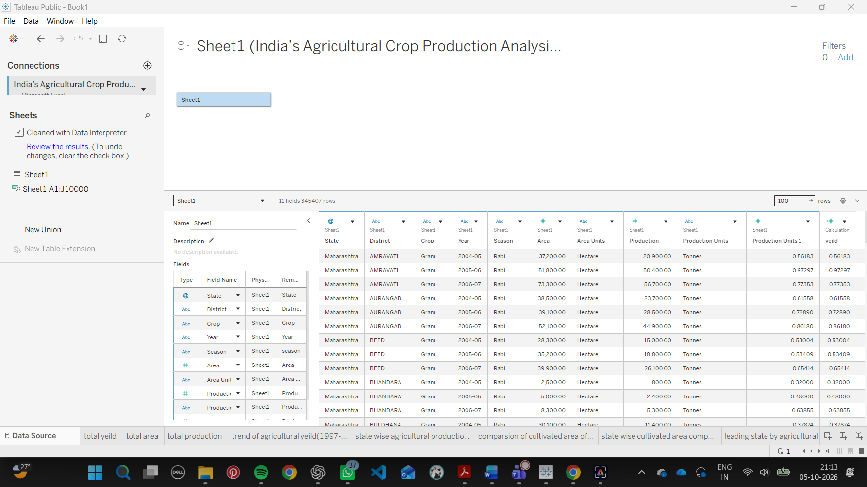
Figure 1: Tableau Data Source tab showing the Excel connection, 11 fields and 345,407 rows.
Fields available in the data source:
Field | Type | Description
State | Geographic (Text) | Name of the state or union territory; used for map and state-wise charts
District | Text | District within the state
Crop | Text | Crop name (for example Rice, Wheat, Cotton (lint), Soyabean, Sugarcane, Coconut)
Season | Text | Autumn, Kharif, Rabi, Summer, Whole Year or Winter
Year | Text | Agricultural year, for example 1997-98
Area | Measure | Cultivated area
Area Units | Text | Unit in which area is recorded (Hectare in the sample rows)
Production | Measure | Quantity produced
Production Units | Text | Unit of production: Tonnes, Nuts or Bales
Production Units 1 | Measure | Numeric column in the source; its row values match the yeild calculation
yeild | Calculated measure | Production divided by area (created during preprocessing)

3.2 Data Quality Report
The data was inspected in the Tableau data pane and in the filter lists. The following issues were identified and handled or documented.
Issue | Observation | Handling
Inconsistent crop names | The same crop appears under slightly different spellings, for example “Rapeseed & Mustard” is listed twice with different spacing, and some names start in lower case (“other oilseeds”). | Names were reviewed; analysis focuses on the major crops, so variants do not affect the top-N views. Merge using aliases / grouping in future.
Mixed production units | Production is recorded in Tonnes, Nuts and Bales, so a plain SUM mixes different units. | Unit type was kept as a dimension; a separate donut chart shows the distribution by unit. Limitation noted in the conclusion.
Season coding | Many perennial or long-duration crops are recorded under “Whole Year”. | Retained as given; a season set was created for the season view.
Incomplete last year | The year-wise production chart shows no production bar for 2020-21, and the yield trend has 23 marks instead of 24. | Treated as a likely incomplete-data effect and flagged in the observations.
Missing or zero values | Some State–District–Crop records have blank or zero production or area. | Aggregations (SUM) ignore blanks; the yield calculation uses totals so division by zero is avoided at row level.
Field data types | Year is stored as text; State was assigned the geographic role. | Year used as a discrete dimension; State geographic role enables the map.

3.3 Data Exploration and Preprocessing
The following steps were carried out after connecting to the data source:
- Exploration: Dimensions and measures were reviewed in the data pane. Overall totals were checked: Area ≈ 4,031,130,486 and Production ≈ 330,997,839,211.
- Data cleaning: Data Interpreter was enabled on the Excel source and its results were reviewed before building the worksheets.
- Geographic role: The State field was assigned a geographic role so that Tableau generates Latitude and Longitude for the filled map.
- Calculated field – yeild: Created as SUM([Production]) / SUM([Area]). This gives an overall yield of 330,997,839,211 / 4,031,130,486 ≈ 82, which matches the dashboard KPI.
- Additional fields: A helper calculated field (Calculation1) and a Season Set were created to support the season view. Production Units 1 is a numeric column that comes with the source.
- Filters: Season, Year, Crop and State were used as context and dashboard filters.
- Actions: Filter actions on Crop, Season, State and Year were added so that selecting a mark updates the related views.
- Formatting: Worksheet titles, shading, number formats (for example 0.00M, 10B) and a consistent blue-based palette were applied.

4. Data Visualization

4.1 Framing Business Questions
No. | Business Question | Worksheet
Q1 | What are the overall area, production and yield of Indian agriculture? | Total area, total production, total yield (KPIs)
Q2 | How has agricultural yield changed from 1997 to 2021? | Trend of agricultural yield (1997-2021)
Q3 | Which states lead agricultural production? | Leading state by agricultural production
Q4 | Which states have the largest cultivated area? | State wise cultivated area comparison
Q5 | Which crops occupy the most cultivated area? | Comparison of cultivated area of crop
Q6 | How is production distributed geographically? | State wise agricultural production distribution (map)
Q7 | How did total production change year by year? | Year wise total agricultural production
Q8 | How much does each season contribute to production? | Season wise agricultural production share
Q9 | How is production divided by unit type? | Production distribution by unit type

4.2 Developing Visualizations

4.2.1 Trend of Agricultural Yield (1997–2021)
A line chart was built with Year on Columns and AGG(yeild) on Rows, with AGG(yeild) also on Color to give a gradient from 3.37 (lightest) to 50.62 (darkest). The four action filters (Season, Year, State and Crop) are applied, so the chart updates when a mark is selected in another chart on the dashboard. The sheet shows 23 years and the Year axis is sorted by yield.
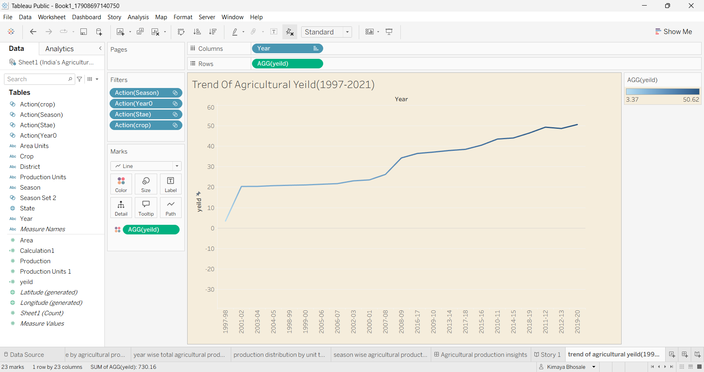
Figure 2: Trend of agricultural yield (Year vs AGG(yeild)) with action filters.
Insight: In the filtered view, yield rises from about 3.4 to about 50.6, with a sharp jump after the first year and a steady climb in the later years. Because the axis is sorted by yield, the year-by-year pattern is easier to read from the year-wise production chart in 4.2.7.

4.2.2 Comparison of Cultivated Area by Crop
A horizontal bar chart with SUM(Area) on Columns and Crop on Rows was created. A Top 4 by SUM(Area) limit was applied to the Crop filter, so only the four largest crops are shown. Filters on Crop, State and Year were added.
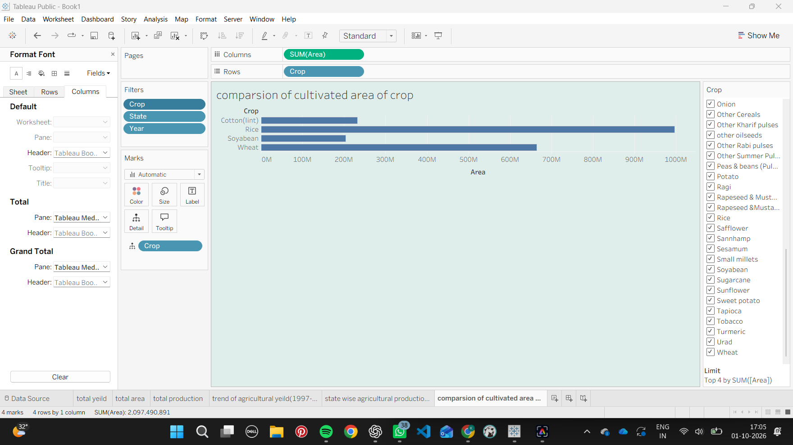
Figure 3: Top 4 crops by cultivated area.
Insight: Rice has by far the largest cultivated area (close to 1,000 million units), followed by wheat (about 650–670 million). Cotton (lint) and soyabean follow with much smaller areas. The top four crops together account for about 2,097 million area units.

4.2.3 State-wise Cultivated Area Comparison
A column chart with State on Columns and SUM(Area) on Rows was built, sorted in descending order, with State on Color and a Top 5 filter on State. Season, Year and Crop filters were added.
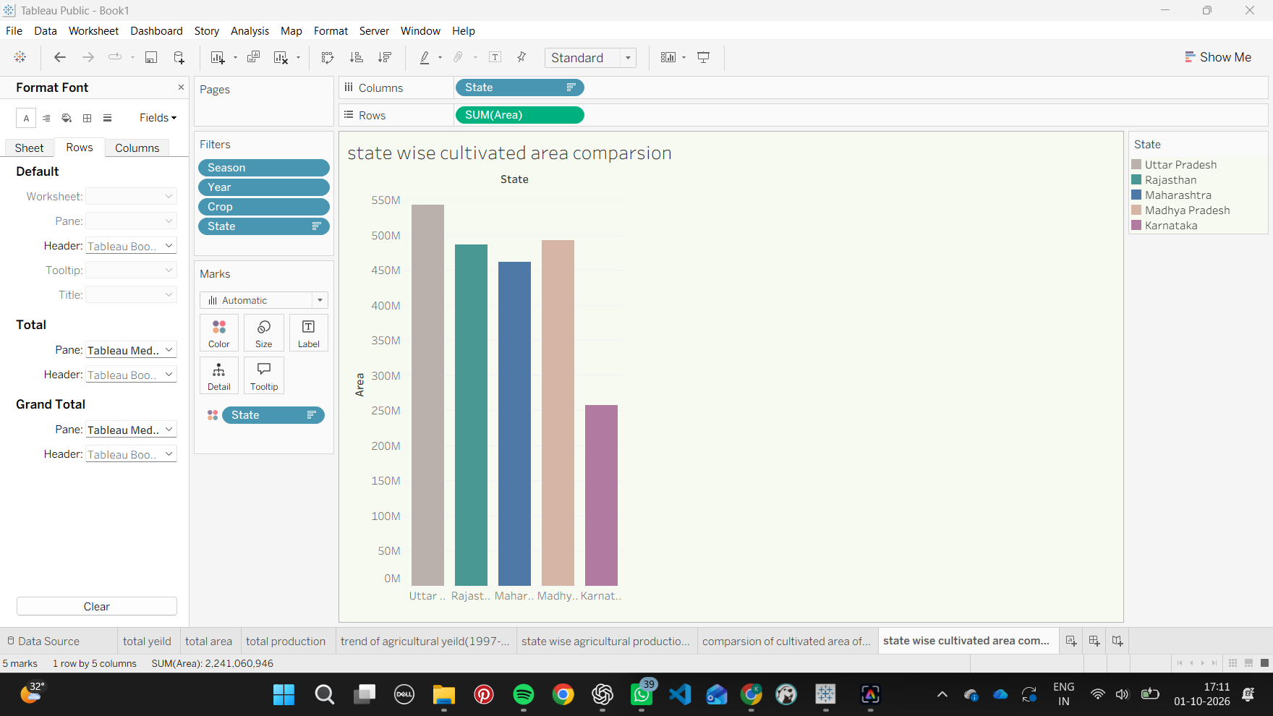
Figure 4: Top five states by cultivated area.
Insight: Uttar Pradesh has the largest cultivated area (about 540 million), followed by Madhya Pradesh, Rajasthan and Maharashtra, with Karnataka fifth (about 260 million). These five states together cover about 2,241 million area units.

4.2.4 Leading State by Agricultural Production
State on Columns and AGG(yeild) on Rows were used to create a bar chart limited to five states. SUM(Production) and the four action filters (Season, Year, State and Crop) are on the filter shelf, so the chart responds to selections made on the dashboard.
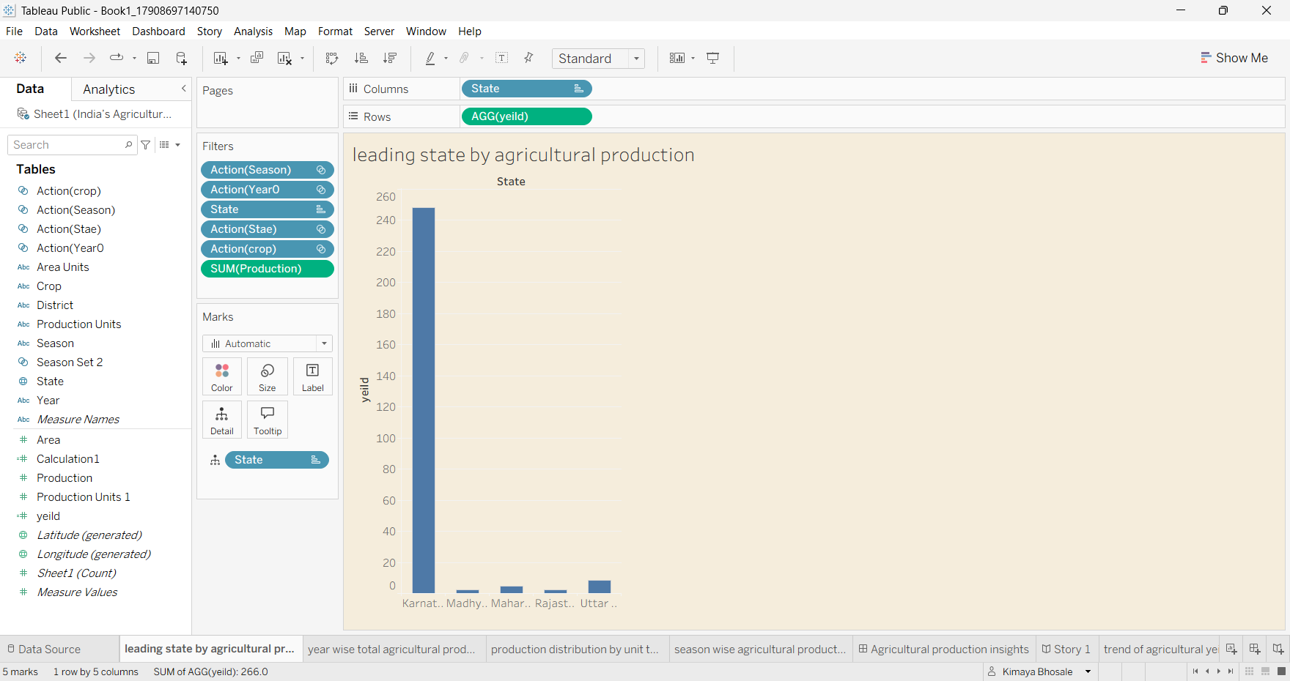
Figure 5: Leading state by agricultural production (AGG(yeild) by State) with action filters.
Insight: Karnataka stands out with a yield of roughly 250, while Madhya Pradesh, Maharashtra, Rajasthan and Uttar Pradesh are in single digits. This is likely influenced by crops such as coconut that are recorded in nuts rather than tonnes, so it should be read together with the unit-type chart in 4.2.6.

4.2.5 Season-wise Agricultural Production Share
A pie chart was created with Season on Color, Label and Detail, SUM(Area) on Angle and SUM(Production) on Size and Label. The view includes a Season legend, a SUM(Production) size legend (330,997,839,211) and a label for the Whole Year segment (317,910,429,998).
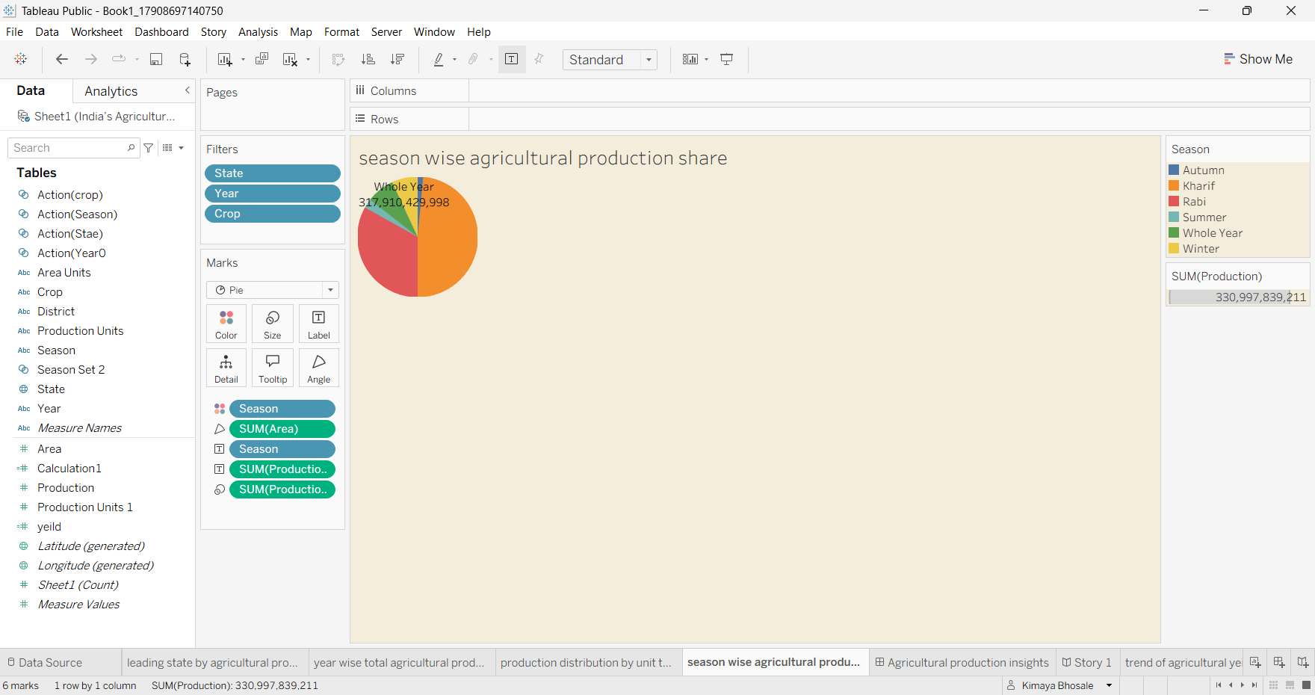
Figure 6: Season-wise agricultural production share (pie chart).
Insight: The “Whole Year” category contributes about 317.9 billion of the 331.0 billion total production (roughly 96%), while seasonal categories such as Autumn (about 105.7 million) are very small in comparison.

4.2.6 Production Distribution by Unit Type
A radial (donut) chart was created using Production Units on Ring and SUM(Production) on Angle, with filters on Season, Year, Crop and State. It shows how the total production of about 330.99 billion splits across Tonnes, Nuts and Bales.
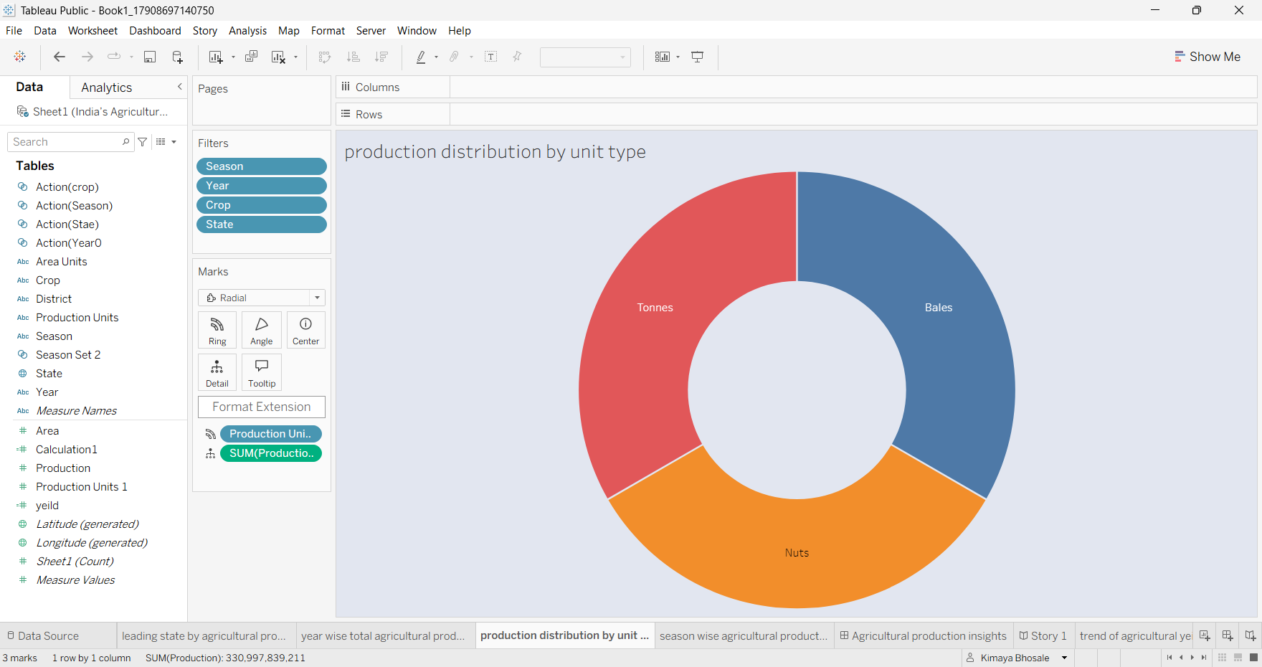
Figure 7: Production distribution by unit type (donut chart).
Insight: Production is recorded in three unit types: Tonnes, Nuts and Bales. Because these are different physical units, totals combining them should be interpreted carefully.

4.2.7 Year-wise Total Agricultural Production
A column chart was built with Year on Columns and SUM(Production) on Rows, with Year also placed on Color so that each agricultural year has its own colour and legend entry. Filters on Season, State, Crop and Year were added. The sheet has 24 marks.
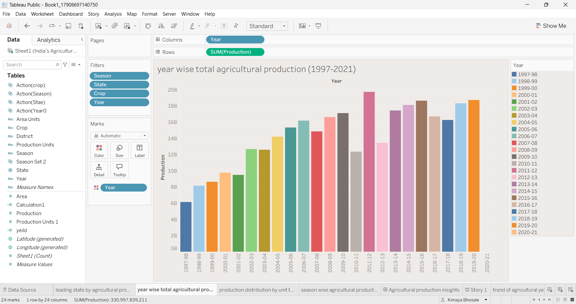
Figure 8: Year-wise total agricultural production (1997-2021).
Insight: Production grows from about 6 billion in 1997-98 to a peak of about 19.7 billion in 2011-12, with dips in 2010-11 (about 12.4 billion) and 2012-13 (about 13.5 billion), and reaches about 18.7 billion in 2019-20. No bar is drawn for 2020-21, which supports the view that data for the final year is missing.

4.2.8 Other Worksheets
- Total area, total production, total yield: KPI-style sheets that show 4,031,130,486 (area), 330,997,839,211 (production) and 82 (yield).
- State-wise agricultural production distribution: A filled map of India coloured by production, from about 109 (light green) to 130 billion (dark green), with a Season filter. It is used in the dashboard and the story.

5. Dashboard

5.1 Dashboard Design File
The dashboard “Agricultural production insights” combines the worksheets into one interactive view. A beige background and a consistent blue palette give a uniform look, and each chart has a clear title in the same font. The layout uses tiled containers so that it resizes properly. The size is set to “Fit to width” with a height of 1407 and a Phone device layout is available in Device Preview.
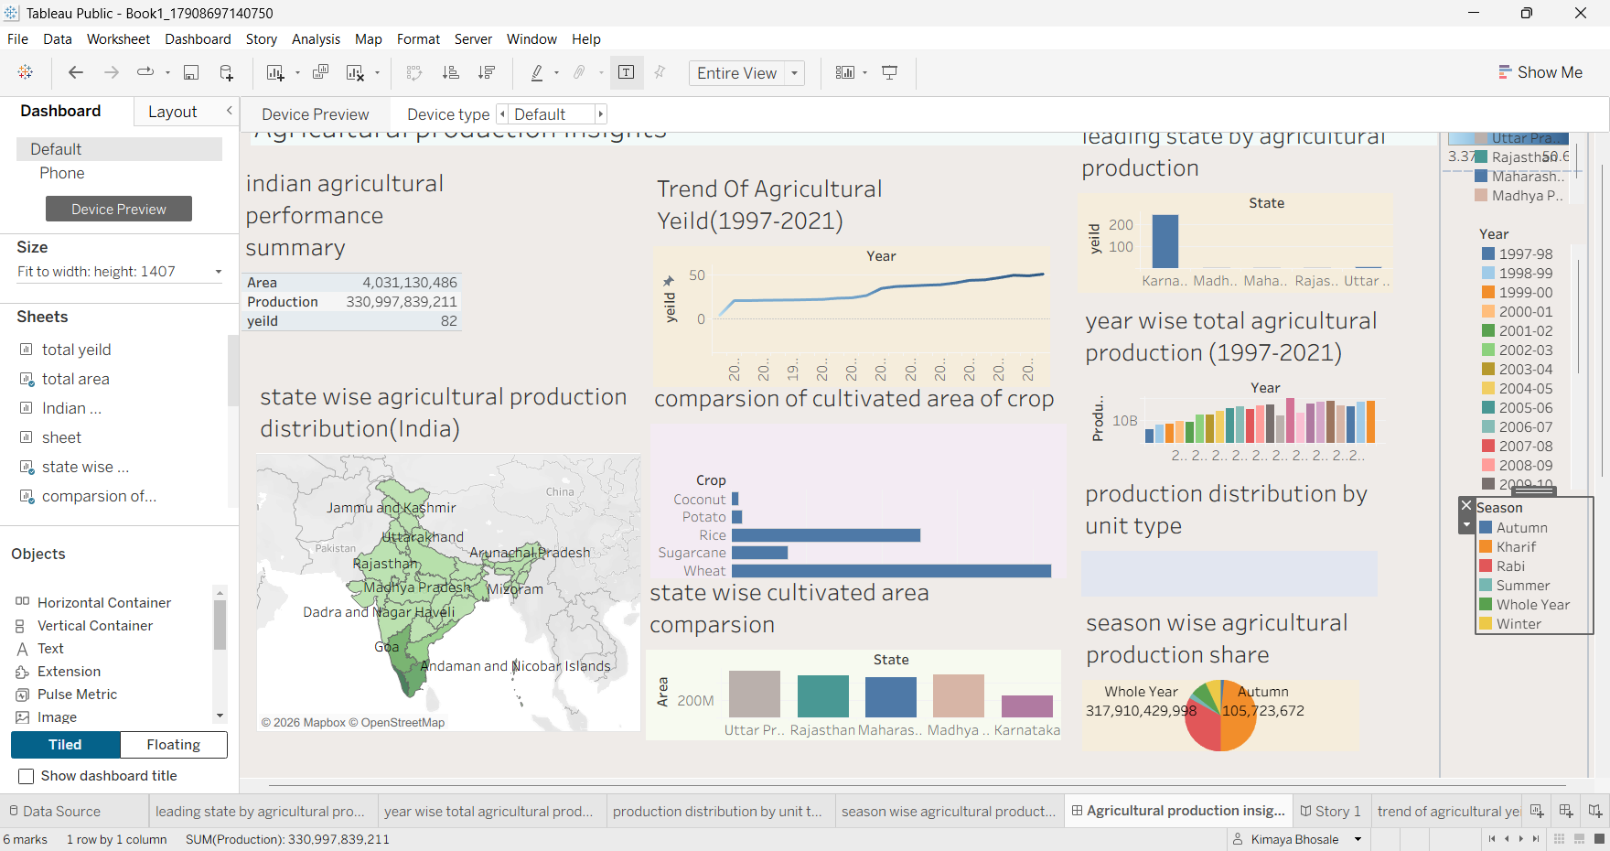
Figure 9: Agricultural production insights dashboard in layout mode (Tableau Public).
Dashboard component | Purpose
Indian agricultural performance summary | KPI block: Area, Production and yield (82).
State wise production distribution (map) | Geographic view of production by state.
Trend of agricultural yield (1997–2021) | Line chart of yield by year.
Comparison of cultivated area of crop | Bar chart for the largest crops by area.
State wise cultivated area comparison | Top five states by area.
Leading state by agricultural production | Top states by production.
Year wise total agricultural production | Production for every year, coloured by year.
Production distribution by unit type | Donut chart by Tonnes, Nuts and Bales.
Season wise agricultural production share | Pie chart of seasons, with a Season legend filter.

Interactivity is provided by the Year and Season legends, the Crop and State filters, and filter actions (Crop, Season, State and Year) so that clicking a mark in one chart filters the others.

6. Report

6.1 Story Design File
A Tableau Story (“Story 1”) was created to present the findings in a guided order. The story uses the worksheets directly as story points, and each point carries a caption. The first story point, “State wise agricultural production distribution”, shows the filled map of India with the Season filter and a production colour legend. Further story points can be added from the same worksheet list (total area, total production, yield trend, crop area comparison, state-wise area, leading state, year-wise production, unit-type distribution and season share) to extend the narrative.
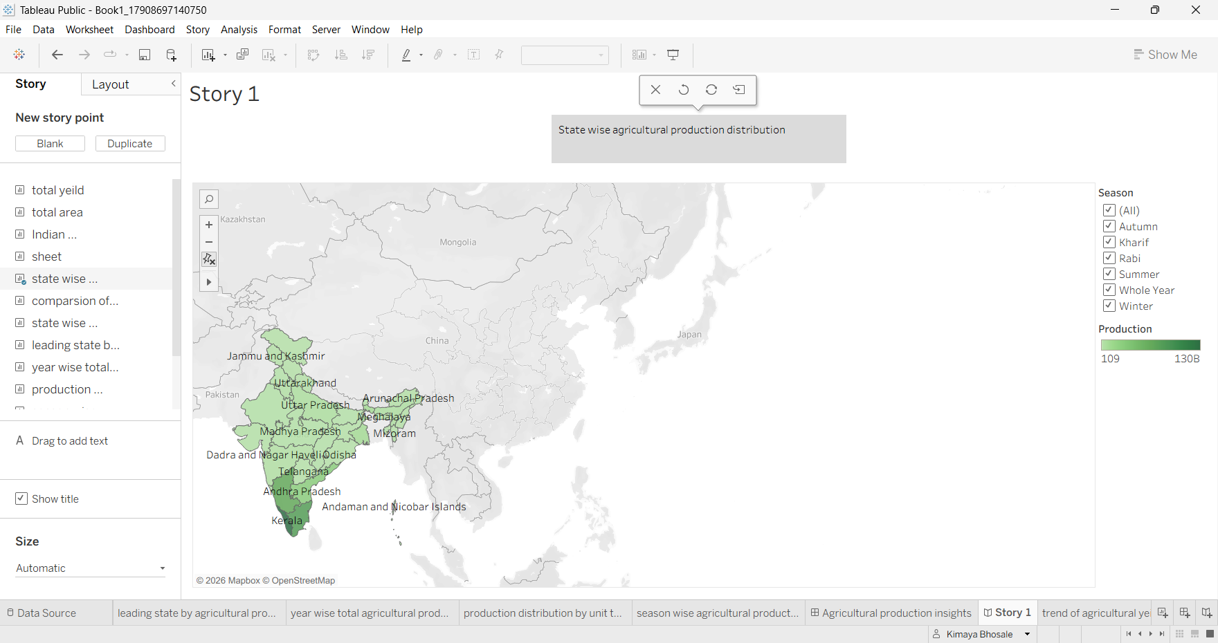
Figure 10: Story 1 – state wise agricultural production distribution.

7. Performance Testing

7.1 Utilization of Data Filters
Filter | Type | Where used
Season | Dimension filter / legend filter | Production by unit type, state-wise area, leading state, season share, map
Year | Dimension filter / legend filter | Yield trend, crop area, state-wise area, leading state, unit-type donut
Crop | Dimension filter (Top 4 by SUM(Area) on crop comparison) | Crop comparison, state-wise area, leading state, donut, yield trend
State | Dimension filter (Top 5 on state charts) | Crop comparison, state-wise area, leading state, donut, yield trend
Action filters | Dashboard actions on Crop, Season, State and Year | Dashboard interactivity across all charts

Filters were applied to every visualization so that the dashboard responds quickly, and Top-N limits on Crop and State keep the charts readable and reduce the number of marks that Tableau must draw.

7.2 Number of Calculation Fields
Field | Description
yeild | Calculated field: SUM([Production]) / SUM([Area])
Calculation1 | Helper calculated field used in the analysis
Season Set / Season Set 2 | Sets created on Season for the season-wise view
Production Units 1 | Numeric column that comes with the source (not a calculation)

In total, the workbook uses two calculated fields (yeild and Calculation1), plus a season set (Season Set / Season Set 2).

7.3 Number of Visualizations
Element | Count
Worksheets | 11 (total area, total production, total yield, yield trend, crop area comparison, state-wise area, leading state, year-wise production, unit-type donut, season share, state-wise production map)
Dashboard | 1 (Agricultural production insights)
Story | 1 (Story 1)

8. Conclusion / Observation
The project shows that Tableau can turn a large agricultural dataset into a clear, interactive and easy-to-share analysis. The main observations are:
- Overall yield across the dataset is about 82 production units per area unit, from roughly 4.03 billion area units and 330.99 billion production units.
- In the filtered yield view, yield rises from about 3.4 to about 50.6 across 23 years.
- The year-wise production chart shows no bar for 2020-21, so data for the final year is likely incomplete and should not be treated as a real collapse.
- Rice dominates cultivated area, followed by wheat, cotton (lint) and soyabean.
- Uttar Pradesh, Madhya Pradesh, Rajasthan, Maharashtra and Karnataka are the five states with the largest cultivated area.
- The state map shades Kerala darkest (highest production on a scale of about 109 to 130 billion), but this is strongly influenced by crops measured in nuts.
- About 96% of production is recorded under the “Whole Year” season.
- Because production is stored in Tonnes, Nuts and Bales, totals that combine all units have limits, and unit-aware analysis is recommended.

9. Future Scope
- Convert all production values to a single unit (for example tonnes) so that state and crop comparisons are fully reliable.
- Standardize crop names and merge duplicate spellings using Tableau groups or a mapping table.
- Add district-level drill-down and a state/crop selector parameter.
- Add rainfall, temperature, irrigation and fertilizer data to study the drivers of yield.
- Add forecasting (Tableau forecast or a Python/R model) for production and yield.
- Update the dataset with recent years so that 2020-21 and later years are complete.
- Include market price data to link production with farmer income.

10. Appendix

10.1 Source Code
The project is built using Tableau’s drag-and-drop interface, so there is no program source code. The calculated field used is given below.
yeild = SUM([Production]) / SUM([Area])

10.2 GitHub & Project Demo Link
Item | Link
GitHub repository | [paste GitHub link]
Tableau Public dashboard | https://public.tableau.com/app/profile/kimaya.bhosale3704/vizzes
Project demo video | [paste demo link]

